**Heels behind the wheels!**

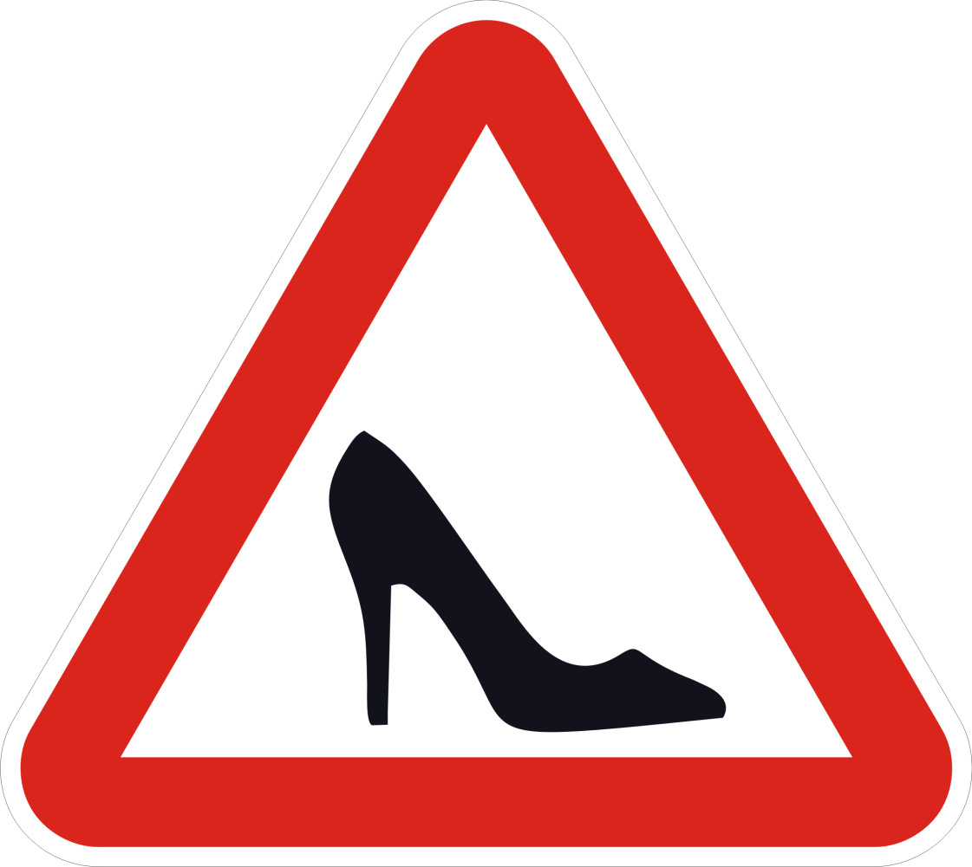

Who are the better drivers- men or women? I don’t think any gender related argument has been more heated than the one that rages behind the wheel. The statistics say that while women cannot park the car, men cannot avoid violating traffic rules! There have always been jokes about who drives better. Even driving is not sex-blind! Women aren’t trying to prove any point by slipping into the driver’s seat, for most men and women it’s a necessity. All and all, the bottom line is that no matter which gender the driver belongs to, all drivers need to be careful when on the road. Driving is serious business and the age old “fight” of who is the better driver, men or women, will not solve the problems faced by drivers and pedestrians alike. Only taking driving more seriously and obeying all traffic rules and regulations will help make driving safer for both the genders.

If you are a woman, know how to drive and are not being stopped from driving, consider yourself lucky. Saudi women are fined for driving. Women drivers in Saudi Arabia are just as rare as item girls in Saris, because Saudi Arabia prohibits its women from driving. And you thought you lived in an egalitarian world? On 26th October, 2013 Saudi women held a campaign to defy the ban on women drivers, taking to the streets as part of a push to allow women to attain driver's licenses. Thousands of people have signed an online petition supporting the protest, which government and religious officials have spoken out against. A Saudi cleric who had hoped to discourage female drivers said that sitting behind the wheel of a car could harm a woman's ovaries. The most bizarre thing I have ever heard! Women drivers are considered a threat to their male ego. An insecurity that stems from the fact that the fairer sex is able to do what the men are traditionally supposed to do. You don’t have to be an activist to realize how irrational this is.

There are certain things you just cannot relate to a woman i.e. drunk driving, violation of traffic rules, and indulgence into any kind of clash on road. On the flip side, it is a common perception that if you see anyone not driving well, the first thought that crosses your mind is– it must be a woman. Partly due to this notion it was impossible to imagine a woman chauffeur a few years back. But, female cab drivers have already broken into India’s hostile male profession. Sakha Consulting Wings, a project initiated by Meenu Vadera of the Azad Foundation, in 2008, is a voluntary group which helps disadvantaged women look for employment. There are a handful of other such initiatives in New Delhi and other Indian cities that are tapping into a new but promising market for cabs driven by women. They select women from the minor sections of the society and train them to drive cabs professionally. The benefits are that it gives these women a better life as well as a socio-economic freedom. It ensures livelihoods with dignity for resource-poor women who become drivers, and on the other hand, offers safe mobility for female passengers.

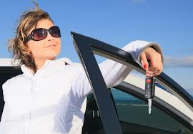**There is more to it than getting a license to drive. It means going to work in an openly hostile field, where road rage, physical threats and sexual violence are often sparked by the sight of a woman behind the wheel. Though, female passengers would feel more comfortable traveling with a female cab driver,**an apparent question of safety of these female taxi drivers comes into picture as these female drivers like their male counterparts have to travel in the wee hours of the night. To face such a situation boldly, female taxi drivers are fully trained in self defense and car maintenance. Women will always have to walk that extra mile; there are always going to be perils of a round-the-clock job for them. But the alpha females have never feared to challenge convention!

For the record, I drive. I love driving. I drive well and I know it. It gives me a thrill, and this thrill does not come from high speed driving or jumping red lights. It comes from not having to depend on your parents. It feels so liberating steer your own path. And while you do that, just don’t forget to wear your seat belt!

Diksha Mahajan

IT-4th year